Challenge 1 - Kickstarting with Excel

**Project overview/Purpose**

1. To acquaint the user with the fundamentals of excel.
   1. Basic formulas
   2. Basic cell formatting
   3. Pivot tables
   4. Pivot table charts
   5. Excel charts
2. Perform analysis of the data set to answer basic questions on the Outcomes of the Launch Date and Goals.
   1. Draw two conclusions on the Outcomes of the Launch Date.
   2. Draw a conclusion on the Outcomes based on Goals.
3. Analysis
   1. Determine which category / sub-category had the most chance of being successful and identify the Goal amount necessary for success.

**Outcome of the Launch Date**

Based on the data provided, Plays within the group Theater, during the month of May, has the highest probability of success than any other category or month. May’s statistics are:

1. There were 386 launches in the month of May with 234 successes. This equates to a 60% success rate (Chart 1).
2. With 8 primary categories achieving success, Theater had the most with 111. This represents 47.4% of the primary categories (chart 2).
3. With 18 sub-category subjects achieving success, Plays had the most at 93. This represents 39.74% of the sub-categories (chart 3).

**Outcome based on Goals**

Based on the data provided, the Goal, month and sub-category are key indicators in determining a successful Launch or a failed Launch. In Chart 5, the data shows when the Goal for Plays exceeded the average of successful Launches, the Launch failed. When the average Goal was less than the average of all successful Launches, the Launch for Plays was successful. The following items are represented in Chart 5.

1. The total Goal for successful Launches was $1,756,615 averaging $9,866 per Launch.
2. The total Goal for failed Launches was $10,487,858 averaging $60,556 per launch.
3. For the sub-category of Plays, total successful Launches were $281,844 averaging $3,030 per Launch.

Chart 1

Chart 2

Chart 3

Chart 4

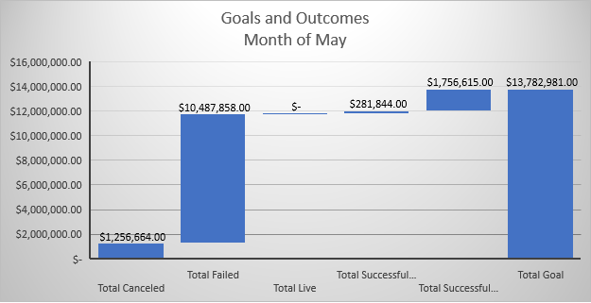

Chart 5